Bahria University,

Karachi Campus



LAB EXPERIMENT NO.

05

LIST OF TASKS

|  |  |
| --- | --- |
| TASK NO | OBJECTIVE |
| 1 | **Using python implement Naïve Bayes with two different splitting ratios on Heart Attack Analysis & prediction dataset to predict the chances of heart failure in a person and performed the following steps:**  * **Data Pre-processing step** * **Fitting Naive Bayes to the Training set** * **Predicting the test result** * **Test accuracy of the result(Creation of Confusion matrix)** * **Visualizing the test set result.**   **Compare the accuracies** |
| 2 | **Design a workflow with the help of Knime to predict whether a user buys a product by clicking the ad on the site based on their salary, age, and gender dataset provided in the lab (i.e. Social network ad dataset).** |

# **Task 1: Using python implement Naïve Bayes with two different splitting ratios on Heart Attack**

# **Analysis & prediction dataset to predict the chances of heart failure in a person and performed the**

# **following steps:**

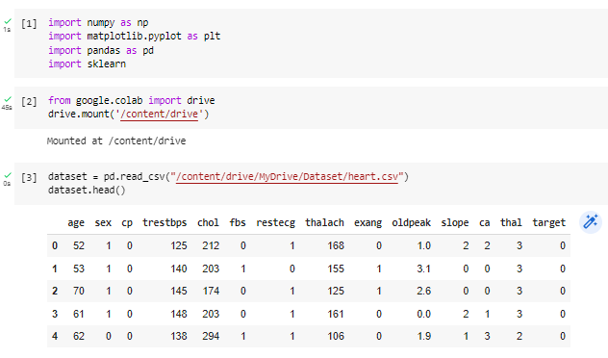

**Test size 30%**

**Test size 40%**

**Confusion Matrix**

**Task 2: Design a workflow with the help of Knime to predict whether a user buys a product by clicking the ad on the site based on their salary, age, and gender dataset provided in the lab (i.e. Social network ad dataset).**

**Solution:**

